

**Weekly COVID Update:**

**Cross-National Policy Comparisons and Canadian Trends in Social Distancing, Social Media Activity, and Government Support**

**June 19, 2020**

**Munk School of Global Affairs & Public Policy, University of Toronto**

**PEARL (Policy, Elections, and Representation Lab)**

**Professor Peter Loewen, Lab Director (peter.loewen@utoronto.ca)**

**Foreword** 4

**Data Visualizations from Dashboard** 5

**Individual OECD Country Profiles** 10

**THE AMERICAS** 11

*The United States* 11

*Mexico* 11

*Chile* 12

**WESTERN EUROPE** 12

*France* 12

*Germany* 12

*Netherlands* 13

*Spain* 13

*The United Kingdom* 14

*Ireland* 14

*Luxembourg* 14

*Portugal* 15

**CENTRAL EUROPE** 15

*Austria* 15

*Greece* 15

*Italy* 15

*Slovenia* 16

*Switzerland* 16

**EASTERN EUROPE** 16

*Czech Republic* 16

*Hungary* 17

*Latvia* 17

*Lithuania* 17

*Poland* 17

*Slovakia* 18

**NORTHERN EUROPE** 18

*Denmark* 18

*Estonia* 18

*Finland* 19

*Iceland* 19

*Norway* 19

**ASIA/PACIFIC** 20

*Japan* 20

*South Korea* 20

*New Zealand* 20

*Australia* 21

*Turkey* 21

*Israel* 21

**Endnotes for Country Summaries** 22

**Partnerships and Contributors** 29

# 

# 

# 

# **Foreword**

Canada, like many countries around the world, is beginning to reopen its economy. At the same time, we are still confronting a serious public health threat in the SARS-CoV-2 virus and in COVID-19.

How are we reopening, compared to other countries? And how are we doing as a country at maintaining social distancing and the public support and attention necessary to sustain the fight against COVID-19?

On our Dashboard, we present unique quantitative data on:

* The openness of the economy on nine different dimensions in 44 different jurisdictions: 34 OECD countries, 5 US states, and 5 Canadian provinces.
* Trends in social distancing in Canada.
* Trends in social media attention to COVID-19 and selected other topics.
* Trends in support for federal, provincial, and local government management of COVID-19.

We also provide a weekly qualitative summary of the actions governments are taking and considering taking to reopen their economies and manage the coronavirus.

Our data are updated weekly. You can subscribe to a weekly update by visiting our website: [www.reopeningaftercovid.com](https://www.reopeningaftercovid.com/).

Please direct any questions or comments to [peter.loewen@utoronto.ca](mailto:peter.loewen@utoronto.ca).

# **Data Visualizations from Dashboard**

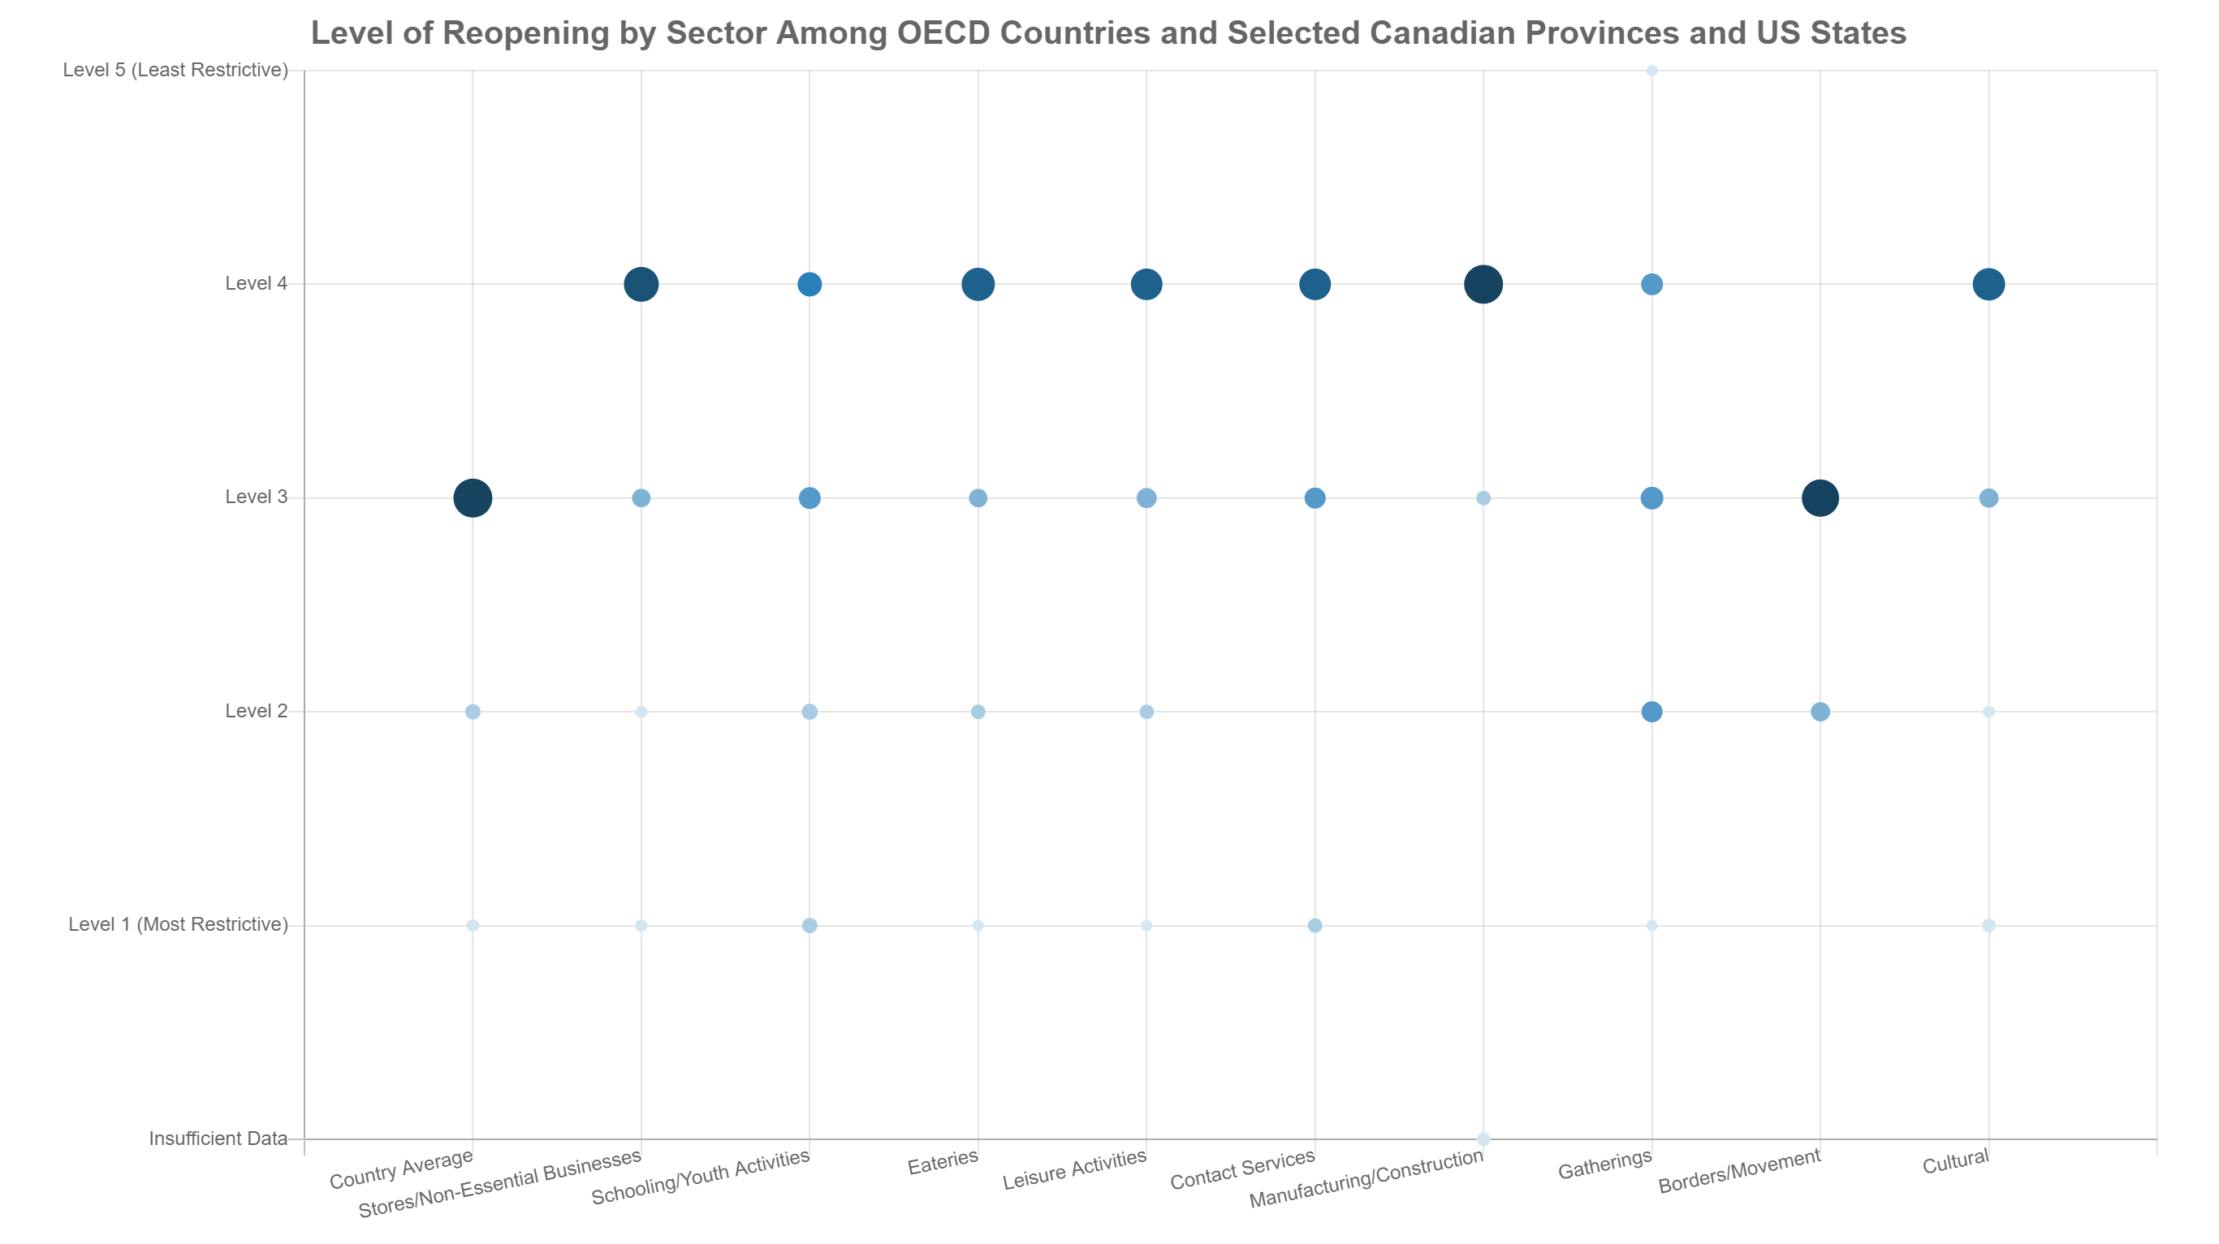

**Figure 1 – Level of reopening among 44 different jurisdictions as of June 19.** The reopening policies of 44 jurisdictions: 34 OECD countries, 5 US states, and 5 Canadian provinces. For each jurisdiction, we classify a total of 9 different sectors: Stores/Non-Essential Businesses, Schooling/Youth Activities, Eateries, Leisure Activities, Contact Services, Manufacturing/Construction, Gatherings, Borders/Movement, and Cultural. Each sector is assigned a level of reopening from Level 1 (Complete Lockdown) to Level 5 (Unrestricted Access). The larger and darker a dot is, the more jurisdictions are at that level of reopening. For details, see [www.reopeningaftercovid.com](https://www.reopeningaftercovid.com/).

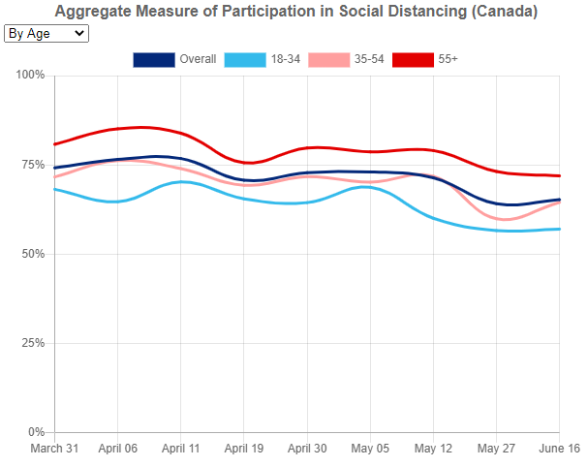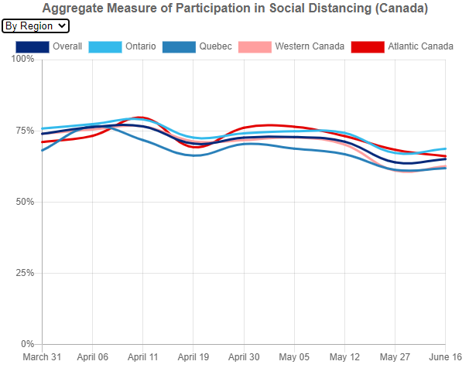

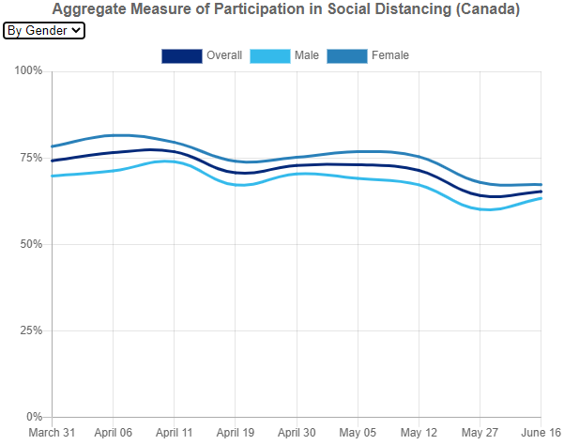

**Figure 2 – Aggregate survey measure of participation in social distancing (Canada).** We asked Canadians whether, as a result of the pandemic, they had taken any of the 6 following actions: avoided crowded places; avoided in-person contact with friends, family, and acquaintances; maintained 2 metre distance from others; avoided domestic travel; avoided public transit; and avoided the grocery store at peak times. The graph displays the percentage of these measures taken by the average survey participant. The surveys used to collect these data were run in partnership with the Media Ecosystem Observatory (MEO). Each survey has a sample size of approximately 2,500 people. For each survey, we worked with a leading sample provider to generate a nationally representative, online sample of Canadians. In addition, following data collection, we applied survey weights to each survey so that—within each province—the sample is representative of the population age and gender.

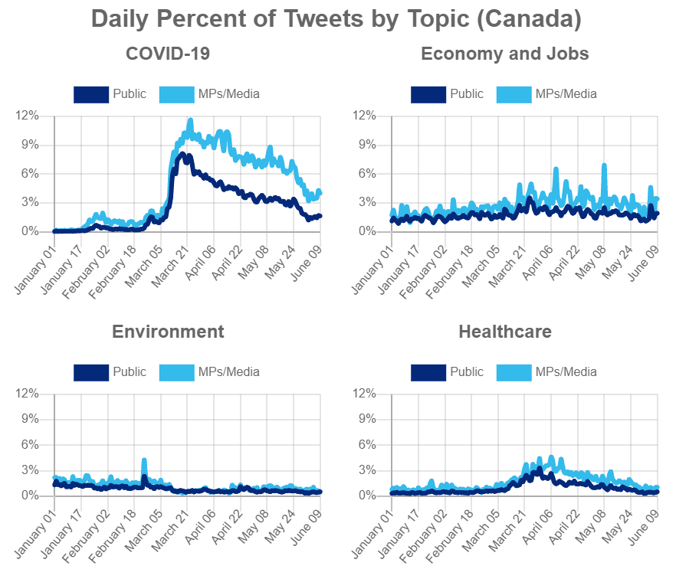

**Figure 3** – **Daily Percent of Tweets by Topic (Canada)**. The graphs report the percentage of daily tweets containing one or more keywords associated with the particular topic. The results are presented separately for MPs, senators, and journalists, on the one hand, and for the Canadian public, on the other. The Twitter data are provided by the Media Ecosystem Observatory (MEO). It aims to capture the entire Canadian Twitter conversation. To do so, MEO identified a set of politicians, political journalists, public intellectuals, and Canadian-specific hashtags and collected every Twitter user that touched one of these themes or individuals. MEO then evaluated each individual, looking at their follower or friending behaviour, biographies, self-identified location, and hashtag use and included them in the sample if they were determined to be algorithmically likely to be Canadian. The dataset contains approximately 200,000 tweets a day. The analysis uses a 10% sample of the public’s daily tweets and the full set of daily tweets from MPs, senators, and journalists.

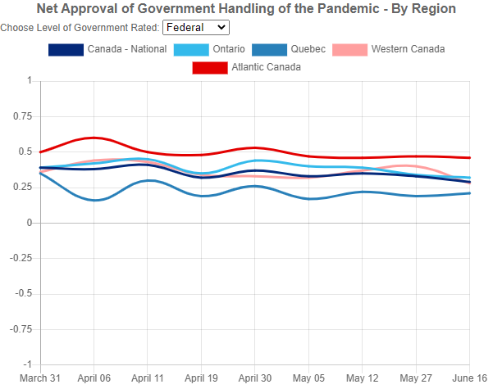 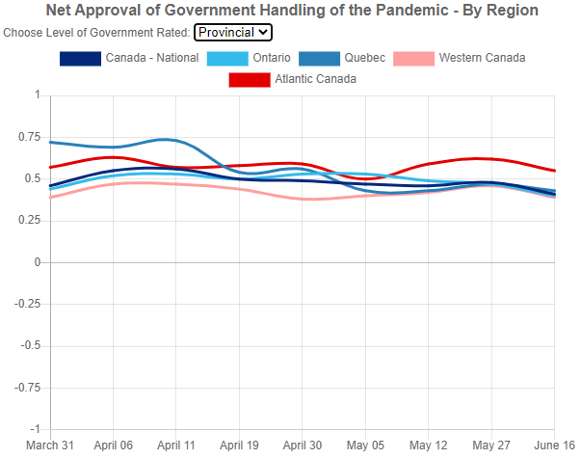

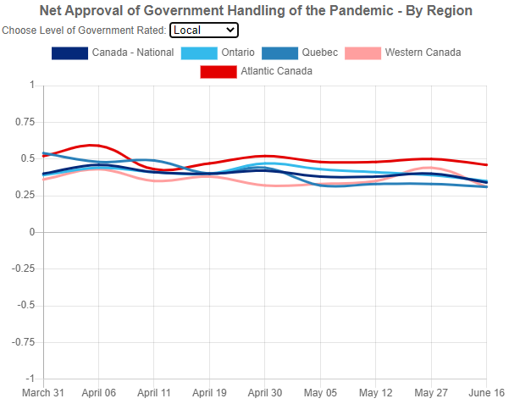

**Figure 4 – Net approval of government handling of the pandemic by region.** We asked Canadians whether they approved of how each level of government (the federal government, their provincial government, and their local government) was handling the coronavirus pandemic so far. To obtain a net approval score, participants’ answers were coded as follows: strongly approve (1); somewhat approve (0.5); neither approve, nor disapprove (0); somewhat disapprove (-0.5); and strongly disapprove (-1). The graph displays the average score. The surveys used to collect these data were run in partnership with the Media Ecosystem Observatory (MEO). Each survey has a sample size of approximately 2,500 people. For each survey, we worked with a leading sample provider to generate a nationally representative, online sample of Canadians. In addition, following data collection, we applied survey weights to each survey so that—within each province—the sample is representative of the population age and gender.

# **Individual OECD Country Profiles**

# **THE AMERICAS**

## *The United States*

At least 18 states reported an increase of COVID-19 cases with reopening.1 Some experts describe the resurgence as a continuation of the first wave instead of as a second wave and maintain that there could be a resurgence in the fall.2 On June 16, the FDA revoked the emergency authorization granted to use malaria drugs for treatment because evidence showed it could have deadly effects and did not always work; however, since it is authorized for other uses, doctors are still able to prescribe it with off-label prescribing.3 The Trump administration announced that the COVID-19 vaccine will be free if people cannot afford it and some commercial insurers have announced that they would pay COVID-19 vaccination costs.4 Non-essential travel, excluding commercial and agriculture travel, remains prohibited at US borders to non-US citizens.5 Several experts urge protestors to take precautions and caution about the threat of large gatherings and rallies.6

* *The East Coast and Midwest*

After weeks of lobbying, on June 15 personal-care businesses, such as hair and nail salons, were allowed to reopen in Michigan, the last state that kept those businesses closed.7 Governor Gretchen Whitmer has extended the state of emergency as Michigan is on track to contain COVID-19, but not out of the woods yet.8 Illinois Governor JB Pritzker announced on June 17 a $900 million financial relief package across ten programs, including rental assistance and an evictions ban through the summer.9 On June 18, Governor Andrew Cuomo announced that New York City is on track to enter phase 2 of reopening on June 22, as the number of confirmed cases continue to decrease (even though the number of active cases continues to gradually increase).10 This will allow restaurants and bars to open for outdoor service, along with offices, indoor retail, hair salons and barbershops, with hygienic conditions.11 On June 17, Maine Governor Janet Mills announced that the three remaining counties were allowed to reopen bars or restaurants for outdoor service, as well as gyms, with face coverings encouraged, but not yet mandatory.12

* *The West Coast and South*

The number of COVID-19 cases is increasing in the South and West.13 On June 11, the Governor of Washington released a plan to reopen schools fall 2020-2021.14 In fall, 15-20% of UCLA classes will be either in-person or hybrid.15 Dr. Fauci explained that an uptick in cases as states open is less concerning than the increase in hospitalizations, which approximately six states are experiencing with reopening. On Friday June 12, Texas and North Carolina reported the highest hospitalization numbers.16 The governor of Texas explained that Texas would continue reopening since despite their hospitalization numbers, hospital beds remain available.17 California will allow food trucks with sanitary restrictions.18 The Director of Health in Orange County, California, resigned after protests at her home and death threats against her for making the use of masks mandatory in May.19 Case numbers are rising in Florida, and some models predict that it could be a new large epicenter of the virus in the US.20

## *Mexico*

Mexican scientists are exploring sofosbuvir as a COVID-19 treatment.21 The Deputy Minister of Health continues encouraging Mexicans to limit contact, social distance and wear masks.22 Parts of Mexico have plateaued while other areas are experiencing more or fewer COVID-19 cases. Mexico's reopening stoplight indicators are determined by case trends, hospital admissions and occupancy, and the number of COVID-19 positive cases.23 During the week of June 15, 16 states progressed from red to orange in the reopening plan. In orange, states can open: restaurants and cinemas at 50% capacity; shopping centres and religious places at 25% capacity; contact services with appointments at 50% capacity; parks, squares, public spaces, gyms, pools and sports at 50% capacity, supermarkets and markets at 75% capacity with maximum one family member inside at once; and professional sports without audiences.24 As of June 9, Cancun, Isla Mujeres and other tourist based regions declared themselves reopened to direct flights from the US as did some hotels that implemented sanitary measures, and capacity limits between 15% and 30% for now. Beaches, clubs and casinos remain closed in those regions.25 Puerto Vallarta reopened hotels with capacity limits, malls, gyms and sporting facilities.26 An agreement between the federal and regional governments to protect the tourism industry allows certain regions to reopen while classified as red, or locked down.27 The US-Mexico border is expected to remain closed to non-essential travel until July 21.28 Health care workers continue to protest for wage increases, medical insurance, PPE and supplies.29

## *Chile*

Chile reported the ninth most cases in the world.30 The Minister of Health anticipates that June will be Chile’s most difficult month during the pandemic and anticipates that 13% of the population will be hospitalized.31 Between May 11 and June 9, a record of 6,498 Chileans died, which is the most deaths in any one month over the past ten years.32 GenoSur, a Chilean biotechnology firm, is working with an American company in Miami to produce sampling collection kits and transport devices for COVID-19.33 As of June 12, additional quarantine measures were introduced in urban areas while quarantines were extended in other regions.34 A minister confirmed that the country’s state of emergency will be extended for another 90 days, with continued sanitary controls, curfews and army presence.35 Between June 11 and 12, fewer Chileans were detained for curfew violations.36 Amid rising new daily cases and death tolls, and scandals about COVID-19 case reporting discrepancies, Minister of Health Jaime Manalich resigned and was replaced by Enrique Paris.37 An Activa Research Citizen Pulso poll suggests that the president’s approval ratings rose to 13.6% while his cabinet’s rejection ratings fell to 79.2% compared to May’s poll results.38

# **WESTERN EUROPE**

## *France*

COVID-19 fatalities and hospitalizations decreased in France this week, but the number of active cases increased with confirmed cases outpacing recoveries.39 Nevertheless on June 15, President Emmanuel Macron announced that all of mainland France is now in the so-called "green zone," including the Paris region.40 Accordingly, cafés and restaurants in Paris were allowed to reopen on June 15, along with some cultural institutions such as the Versailles Palace. On June 15, France's border with other EU states reopened while borders with countries outside the bloc "where the epidemic has been controlled" will reopen on July 1.41 Only travelers from Spain and the UK are required to self-isolate for two weeks, in parallel with current regulations in those two countries.42 The contact tracing app in France may not be able to connect with others across the EU because it stores data centrally; moreover, only 2% of the population (1.5 million people) has downloaded and activated the app, which was launched on June 2.43 Most surprisingly, Macron announced that every preschooler and pupil under the age of 16 will be required to go back to school on June 22 in mainland France. On June 16, a parliamentary commission of inquiry into the government's response to the COVID crisis was opened. This inquiry has extensive powers of investigation, where its summons are legally compulsory, its hearings are held under oath, and its members can carry out document checks for the next six months.44

## *Germany*

This week, the average reproduction rate (R) of COVID-19 in Germany remained below the 1.0 target.45 However, on June 17, Germany reported a spike of 1,100 cases due to an outbreak at a Toennies GmbH meatpacking plant in Guetersloh, which accounted for 657 positive cases. The plant was closed, 7,000 people were quarantined, and schools and childcare facilities in the region were ordered to close starting June 19 until June 29, nevertheless there are no plans for a broader lockdown.46 This is a part of Germany's local intervention strategy, where each municipality/state has the authority to close sectors if there is an outbreak.47 This outbreak prompted officials to criticize the living conditions of workers in the meatpacking industry, where social distancing is impossible.48 On June 16, Germany launched its contact tracing app Covid-Warn-App. It is intended to complement, not replace, existing low-tech contact tracing efforts, which rely on calling people who test positive to ask about their movements within the last 48 hours.49 The launch comes at a time when EU states are discussing guidelines for interoperability to track cases across the EU, with the creation of a central gateway to handle data traffic between the apps based on the Google-Apple standard.50 While using the software is voluntary, its success depends on how many people download and register with the app. In response to privacy concerns, the app has an added layer of security protecting the identity of the user from other users and from the government.51

*Belgium*

On June 15, non-essential travel resumed within the EU and Schengen zone. While arrivals are not subject to quarantine, airports have implemented measures which include temperature checks before departure and mandatory face coverings.52 Non-essential travel outside of the EU and Schengen zone remains banned.53 The distribution of face masks ordered by the federal government began on June 15, more than a month after the initial pledge to provide each resident with a mask. Over a 10 day period, 4,800 pharmacies will be responsible for distributing masks in stages organized by age group.54 A government decision to distribute 10 free rail tickets to all Belgians has been publicly opposed by the National Rail Company. The company’s board of directors agrees it would endanger the safety and health of passengers and staff and plans to postpone implementation of the decision to a later date when public health conditions improve.55 Two nursing federations are taking the government to court after accusing authorities of negligence toward health care staff and a lack of foresight in their management of COVID-19.56 The Interior Minister urged local officials to limit the right to protest in the interest of public health, in order to avoid a potential second wave.57

## *Netherlands*

Effective June 15, shared toilets and ablution facilities belonging to outdoor and high-performance sports centers, zoos, amusement parks, public swimming pools and public libraries opened to the public, along with major educational institutions. Lecture halls are allowed to fill up to a maximum capacity of 20 percent in universities, with classes set to run between 11 a.m. and 3 p.m, and then again after 8 p.m. to avoid rush hour congestion.58 On the following day, travel advice to 16 European countries also relaxed to the public, with holiday trips allowed to most EU countries. The advice went from code orange, which discourages all unnecessary trips, to code yellow, which warns of safety risks to travelers. Spain, Greece, Cyprus and Ireland are not yet among code yellow countries.59 An entry ban to the people arriving from outside the EU is also extended until July 1. However, the ban is not applicable to EU citizens, and their family members. Holders of a residency permit or long-stay visas for the Netherlands, people with vital functions, such as healthcare- and border workers, people employed in transportation of goods, and even diplomats and military personnel, are also exempted from the ban.60

## *Spain*

Schools in Spain remain closed, but some schools are testing new norms for the fall in voluntary classes. The tests include checking for masks and fevers at the gate, increased hand washing, disinfecting chairs and desks, and social distancing with and without masks.61 By June 15, 70% of Spain entered phase 3. Spain’s new normality is expected to begin June 21, although Galicia has already entered the new normality. Some sanitary measures implemented early in the outbreak remain.62 As of June 21, tourism will reopen to European and Schengen travellers, who must be nationals of the countries they arrive from, with the exception of Portugal whose travellers are not permitted until July.63 Tourists will only be permitted to visit parts of Spain in phase 3 and with infection rates of less than nine per 100,000 people.64 These tourists will not have to quarantine, but must stay for minimum five days and prove their return trip. Other regions will still require a 14 day quarantine. The remainder of Spain is anticipated to reopen to tourism in July as the lockdown eases.65 Andalucia wants to create a health passport for foreigners, both for tourists and immigrants, and to collect health tests and PCR test results from tourists and visitors.66 Federally and in Valencia and the Canary Islands, there are concerns about people entering the country through irregular immigration and enforcing testing and isolation in those cases.67

## *The United Kingdom*

The UK's COVID-19 death toll has surpassed 53,000.68 Watchdogs and authorities are using the number of excess deaths, which is currently double the average number of deaths last year, as a method for measuring the full impact of the COVID-19 crisis directly and indirectly.69 Unlike most countries, the UK is not tracking the number of people who have recovered from COVID-19. This has made public health experts question the effectiveness of contact tracing, since they do not know who has recovered.70 The Government is abandoning the COVID-19 app it developed in May, and will now subscribe to the Apple-Google model, which recognizes 99% of smartphones.71 This U-turn has caused the official opposition to question how much money was spent on the original app. On June 15, "non-essential" retailers - those selling fashion, toys and books, among other items - reopened across England.72 Hygienic restrictions are in place, such as a limit on the number of customers allowed in each store, discouraging customers from unnecessarily touching merchandise and closing fitting rooms. Without tourists, businesses expect to see around 10 to 15% of its normal customer base this week.73 Non-essential retail stores in Scotland and Wales have not opened.74 Plans to reopen eateries by July 4 might be delayed.75 President Macron will not have to quarantine for 14 days when he travels to London on June 18 to meet with Prime Minister Boris Johnson for the 80th anniversary of the French Resistance and post-Brexit discussions.76

## *Ireland*

On June 15, all shopping centres reopened with strict social distancing measures in place, including the closure of dining and seating areas around the stores to lessen dwell time among shoppers and discourage browsing for longer periods of time. To enforce social distancing with the stores, only a certain number of customers are allowed inside. Visits to nursing homes and residential care facilities are also allowed with pre-reservations of half an hour and a compulsory application of mask and gloves. Despite masks not deemed mandatory, people have been advised to wear them on public transport, in enclosed spaces and when visiting older people.77 Creches, pre-schools, hotels, restaurants and bars which provide table service, are scheduled to reopen within phase three of the relaxation strategy, effective June 29.

## *Luxembourg*

On June 15, all playgrounds reopened to children, with no compulsory requirement to wear masks for those under the age of 13. Restaurants can host ten people at one table. Gatherings of people are no longer limited, but groups exceeding twenty people will have to adhere to stricter safety regulations. Outdoor and indoor events with more than twenty people can be organised, as long as there are designated seats for all participants. Safety distances of 2 metres must be assured, or people are obliged to wear masks.78 However, effective 16 June, it is no longer a legal requirement to wear a protective mask in a car, but it is compulsory on public transport due to crowding.79 In an announcement on the following day, RyanAir, announced the resumption of flights from Luxembourg Airport to 10 destinations abroad, effective July. The relaunch of flights, however, remains dependent on travel authorisations by each country.80 However, flights to Germany are available given that it re-opened all its borders with Luxembourg for all types of travel on June 16.81

## *Portugal*

On June 15, the Metropolitan area of Lisbon entered phase three of deconfinement, a week after the rest of the country entered the third phase, following a reduction in the outbreak of COVID-19 cases. The same rules now apply in Lisbon as the rest of the country which includes the reopening of large shopping centres, commercial establishments of over 400 square metres, leisure centres and water parks, along with an increase in gathering limit of 10 to 20 people.82 Even though Spain has announced the reopening of its borders to countries in the EU’s Schengen area effective June 21, free movement to Portugal is only allowed starting July 1.83 Portugal’s Covid-tracking app, ‘stay away’ is due to be launched by the end of June. Through bluetooth technology, it aims to provide ‘rapid alert’ to users who have been in contact with someone who has since been diagnosed with COVID-19. The science and technology minister has guaranteed that all data collected by the app will be anonymous, with the use of it voluntary. The minister expects a number of public and private institutions to recommend the use of the app – suggesting that while it will not be mandatory, people may end up being persuaded to download the software to satisfy requests in their day-to-day routines.84

# **CENTRAL EUROPE**

## *Austria*

Effective June 15, masks are no longer mandatory in shops, schools and tourist areas. Face coverings remain mandatory on public transit, in health facilities and for contact services where social distancing is difficult to maintain.85 While Austrian borders have been open to neighbouring countries since June 4, as of June 16 this extended to all EU countries, except the UK, Sweden, Spain and Portugal.86 Despite reopening the Austria-Germany border, federal police will continue to control the border for immigration and criminal activity.87 Exhibitions, conventions, trade fairs and large meetings can resume across the country, allowing the event industry to resume operations.88

## *Greece*

Tourism season officially began in Greece on June 15 with seasonal hotels, museums, historic buildings, and entertainment parks opening to visitors. Also, international flights will resume to Athens and Thessaloniki airports. Travellers arriving from airports deemed high risk by the EASA will be tested upon arrival and could face quarantines, however, for other travellers there are no requirements and they may only be subject to random testing.89 Direct flights between international destinations and the islands will not resume until July 1, along with direct flights between the US and Greece. The government is implementing several measures which include testing facilities on the islands, designated doctors for each hotel and quarantine zones for those who test positive.90 An increase in the number of cases among several municipalities has led authorities to impose a curfew and restrictions on gatherings and travel. Since Greece has opened its doors to international visitors, resurgence is a concern and authorities are implementing strict measures to avoid outbreaks in cities or tourist areas where there may be crowds. 91 The prime minister said Greece will be prepared in the event of a second wave because of social distancing, protective measures and additional ICU hospital beds.92

## *Italy*

This week, Italy is entering Phase 3 of its gradual unlocking strategy with nearly all businesses reopened. Cinemas and theatres have reopened, but no more than 200 people can attend events at indoor venues and there is a maximum of 1,000 attendees at outdoor events. This rule also applies to museums, art galleries and nightclubs.93 Online booking is required when visiting cultural sites and using contact services. On June 25, summer camps and kindergartens can reopen but classes will not resume for students until September. Despite reopening its borders to travellers from the EU and Schengen area, Italy has not guaranteed reopening to international tourists.94 Regional travel variation exists with arrivals from Rome and Naples being subject to temperature checks and COVID-19 testing at their airports. The prime minister, health minister and interior minister were questioned by prosecutors about the government’s response to the COVID-19 outbreak in an attempt to determine whether there are grounds for criminal negligence charges. Regional authorities and the central government are trading blame for the shortcomings of Italy’s COVID-19 response. The outcome of the investigation will be used as a political tool against the party blamed for the mismanagement. The division between parties is prevalent and has affected how the outbreak was handled, despite hopes for collaboration earlier in the outbreak.95

## *Slovenia*

Effective June 15, public gatherings up to 500 people were permitted in Slovenia and spectators could also attend sporting events again. The 500 person capacity limit at sporting events will include athletes, media, security and support staff. All safety recommendations issued by the National Institute of Public Health continue to apply.96 Slovenia began easing border and travel restrictions on May 15, but after a month the border fence between Italy and Slovenia was taken down because of significant disruptions for town residents. Restriction-free travel to European countries is permitted with controls in place for those arriving from countries deemed high risk, such as the UK and Sweden. Travellers coming from outside of Europe must quarantine for 14 days, including residents who have been outside of the EU for a two week period.97

## *Switzerland*

Switzerland reopened its borders, lifting the remaining travel restrictions for countries in the EU and Schengen zone. While no quarantine is necessary upon arrival, these entry rules and conditions are subject to change depending on epidemiological situations in the countries. Presently, no travellers can enter from Spain.98 No announcements have been made for countries not included, but further easing of border restrictions for incoming guests from outside these areas are expected on July 6 at the latest. 99 The Federal Office of Public Health stated that specific rules may apply for “certain groups of people or for certain types of journeys under specific conditions.” These conditions may include mandatory quarantines or proof of a negative test.100 On June 17, Switzerland’s COVID-19 reproduction rate (R0) rose above one, prompting concerns that the country is prematurely ending its lockdown. “The news [about their reproduction rate (R0) over one] contradicts official claims that the country is winning the battle against the spread of COVID-19” and could be a warning sign for a second wave of infections.101

# **EASTERN EUROPE**

## *Czech Republic*

The Czech government has continued easing COVID-19 restrictions this week and is focusing on reopening the country’s borders to travellers.102 Since June 15, citizens and long-term residents of selected EU+103 countries have been allowed to travel to the Czech Republic without submitting a negative COVID-19 test upon arrival.104 These countries are selected based on a list maintained by the Czech Ministry of Health, which divides EU+ countries into three groups according to their level of risk relative to COVID-19.105 Travellers from “low-risk” countries, such as Spain and Italy, can enter the country without restrictions, while those from “medium-risk” countries, such as Belgium and the UK, are required to submit a negative COVID-19 test upon arrival.106 Sweden and Portugal are currently the only two “high-risk” countries whose citizens are completely banned from entry.107All public gatherings and private events, including festivals, religious services, sporting events, and weddings, can take place with up to 500 participants in both indoor and outdoor settings.108 Large indoor establishments, such as museums, galleries, theatres, and concert halls, are also permitted to admit up to 500 participants at once, provided that a safe distancing can be maintained.109 A state-endorsed contract-tracing app, called “*eRouska.cz*,” has been available to Czech residents for voluntary use on Android and iOS devices since June 11.110 All Czech residents are expected to cover their faces while in close proximity to other individuals, especially indoors, and on public transit.111

## *Hungary*

The Hungarian government has continued easing restrictions related to COVID-19, focusing on facilitating movement between Hungary and other EU+ countries demonstrating favourable epidemiological situations. Since June 5, Austrian, Slovak, and Czech citizens, as well as Hungarians residing in any of these countries, have been allowed to enter Hungary without a mandatory quarantine period.112 All border crossings between Hungary, Croatia, Serbia, and Slovenia were reopened on June 9, permitting citizens from these countries to travel across each respective border without restrictions.113 Visitation for inpatients residing in social institutions and long-term care homes could resume as of June 3, while hospital visits could resume as of June 13, provided that both the visitor and the inpatient are wearing masks and maintain a two metre distance minimum.114 On June 15, all healthcare services could resume without restrictions.115 This means that 80% of the hospital beds previously reserved for COVID-19 patients can now be used for other purposes.116

## *Latvia*

Although Latvia’s nationwide state of emergency came to an end on June 9, some restrictions aimed at preventing the spread of COVID-19 will remain in effect indefinitely.117 Mass gatherings are now permitted to take place with up to 100 participants for indoor events and up to 300 participants for outdoor events.118 By July 1, these limits are expected to increase to 500 participants for indoor venues of 1000m2 or more and up to 1000 for outdoor gatherings.119 Cafes and restaurants have been allowed to reopen at full capacity, provided that they are able to maintain at least two metres distance between each table.120 All Latvian residents are required to cover their faces while using public transport and are encouraged to continue doing so in other public settings.121

## *Lithuania*

The Lithuanian government ended a nationwide quarantine on June 16, but left the country in a state of emergency until further notice.122 This means that citizens and permanent residents of EU+ countries can now travel to Lithuania from countries where the incidence of COVID-19 has not surpassed 25 cases per 100,000 people in the last 14 days.123 On June 10, Ireland, Spain, Italy, Greece, Croatia and Cyprus were added to a list of countries which includes Germany, Latvia, Norway and Estonia from which international flights have been allowed to resume.124 Foreigners travelling to Lithuania from Belgium by land may now enter the country, provided that they self-isolate for at least 14 days upon arrival, while those travelling from Sweden, Portugal and the UK will remain prohibited from entering Lithuania until at least June 25.125 Lithuanian citizens and permanent residents can now return home from any of the aforementioned countries, subject to a 14-day isolation period upon arrival.126 Events and mass gatherings can take place in outdoor settings with up to 700 spectators and/or participants, while indoor events can take place with up to 150 participants.127 These limits are expected to increase to 1000 and 250 participants respectively by July 1.128

## *Poland*

Poland’s government has continued easing restrictions related to COVID-19, allowing hotels to fully reopen all of their facilities, including gyms, swimming pools, bars and restaurants, on June 6.129 On June 12, the Polish-Lithuanian border reopened to citizens and permanent residents of both countries, who can now travel across the border without restrictions.130 On June 13, Poland further reopened its borders to all Polish citizens and permanent residents travelling to Poland from another EU+ country, while all citizens and permanent residents of the EU+ may travel through Poland without restrictions while in transit to another country.131 The Polish government has publicly endorsed “*ProteGo Safe,”* a Polish contact-tracing app now available for download on Android and iOS devices.132

## *Slovakia*

On the recommendation of its Ministry of Health, the Slovak government ended its nationwide state of emergency on June 13.133 On June 10, Slovakia fully reopened its borders to the citizens and permanent residents of 19 countries, including: Germany, Austria, Switzerland, Greece, Hungary and Croatia.134 Travellers looking to enter Slovakia from other countries are required to: submit a negative RT-PCR test for COVID-19 taken within the last 96 hours upon arrival; remain in self-isolation for minimum 14 days; and take an additional test for COVID-19 on the fifth day of isolation.135 Nightclubs are permitted to reopen and the limit on mass gatherings is increased to 500 participants for both indoor and outdoor venues.136 On June 15, restrictions on the number of children allowed to participate in kindergarten and primary school classes was abolished, while students at all other levels will be allowed to return to school on a voluntary basis by the end of June.137

# **NORTHERN EUROPE**

## *Denmark*

A few days after the initial opening of its border to tourists from Norway, Iceland and Germany, Denmark announced that it will open its border to tourists from most European countries on June 27. Eligibility is granted if a country has fewer than 20 cases per 100,000 people over the preceding week. If a country’s infection rate rises to 30 cases per 100,000 people, then tourists will need to quarantine on arrival.138 Tourists need to show that they have booked accommodation for at least six nights before entering the country. Nordic countries will be assessed on a regional basis, which means residents of certain Swedish regions will be able to enter Denmark even as the country’s infection rate as a whole remains high.139 Border restrictions with all other countries are currently set to expire on August 31.140 A town with a large elderly population reported 34 new cases over last weekend in the country’s first major outbreak since the gradual lifting of restrictions began in May. The outbreak is linked to a single long-term care home, but has since spread to two different schools in the town. The Minister of Health said that the outbreak should be taken as a warning to Danes who feel that Denmark is now insulated from the virus.141

## *Estonia*

Estonia will lift its lockdown restrictions on nightclubs and bars on July 1. They will be limited to 50% capacity and a maximum of 100 people, and must adhere to disinfectant requirements. Additionally, the government announced that social distancing measures will become optional, effective immediately.142 In the interim, the Health Board has initiated criminal proceedings against the owners of multiple nightclubs in Tallinn after they were found to be hosting large parties under false pretenses, despite not being allowed to operate until July.143 After a brief spike in the number of new cases last week, the infection rate has returned to where it was in the month before the rise in cases.144 The Head of the Health Board Merike Jürilo has resigned following numerous public disagreements with the government’s Minister of Social Affairs and criticism of her handling of the response to the pandemic.145

## *Finland*

The Finnish government ended the country’s state of emergency this week after over three months. The normal legislative process will now resume and the government will stop issuing executive orders. The government will issue amendments to existing laws to Parliament in August that will enable them to react to a potential second wave without resorting to emergency law in the future.146 Outdoor events of more than 500 people will be permitted to take place, with certain restrictions, on July 1.147 Organizers will no longer need government approval for indoor or outdoor events of that size starting on August 1. Finland will allow restaurants to operate at 75% capacity and resume normal working hours and alcohol sales on June 22. Minister of Science and Culture Hanna Kosonen said that if the pandemic situation continues to improve, the country will lift all remaining restrictions by October 1.148

## *Iceland*

Up to 500 people are now able to gather in Iceland in the country’s most recent lifting of restrictions, with fitness centres and swimming pools able to return to full capacity.149 Over 900 air passengers arrived in Iceland on June 15 after the country allowed access to tourists from the EU/EEA, of whom two tested positive for coronavirus and are now in isolation.150 The government issued new guidelines for tourists who opt to quarantine rather than get tested at the airport, saying they are subject to deportation for violating the rules and may deny them entry if they are deemed to be likely violators.151 The Director of Health said that the country would be able to carry on testing for COVID-19 even if nurses go on strike on June 22, as other healthcare professionals can perform the test. The Head of the Nurses’ Union fought back against this assertion, saying that the Director’s statement undermines nursing as a profession and expressing her hope that other healthcare workers will not cross the picket line in the event of a strike.152

## *Norway*

The government-sponsored contact tracing app will be discontinued in Norway. Data agency officials said that the low infection rate in Norway and the low number of downloads of the app made the invasion of privacy from its operation disproportionate to its benefit for contact tracing.153 Public health officials said they would respect the ruling but vehemently disagreed with the assessment of the app, saying that the decision will weaken the country’s response to the pandemic. Only 600,000 of the nearly 5.5 million people in the country had downloaded the app.154 Family members of Norwegians who live outside the EU/EEA will now be permitted to visit, though they will still be subject to a ten day quarantine on arrival. The new guidelines were issued after a loophole in the previous regulations was discovered that allowed the families of EU citizens living in Norway, but not the families of Norwegian citizens, to enter the country.155

*Sweden*

In one of the few legal restrictions that the government imposed, Sweden has extended its ban on visits to long-term care homes from June 30 until August 31 as the infection rate in the country remains high.156 In line with a recommendation from the European Commission, Sweden extended its ban on travel from non-EU/EEA countries until June 30, with some exemptions for essential workers.157 Furthermore, Sweden will scrap its recommendations against non-essential travel to 10 European countries from June 30. Notably, the list only includes countries that do not have any travel restrictions on Swedish citizens, and therefore does not include Norway, Denmark or Finland. The recommendation against travel to all other EU/EEA countries will be in place until July 15, and to all non-EU/EEA countries until August 31. While not a legally enforceable ban, the recommendation means that non-essential travel will not be covered by travel insurance.158

# **ASIA/PACIFIC**

## *Japan*

Having managed to maintain a limited level of new infections for two weeks, Japan saw more than 70 new infections per day on June 15 and 16. Tokyo continues to be the hotspot of new infections, with nightlife establishments being the most worrisome venues. A contact tracing app is planned to roll out next week. Effective June 12, amusement parks, game centers and internet cafes are allowed to reopen in Tokyo. Bars and restaurants can extend their operation hours from 10 pm to midnight. However, nightlife establishments have been required to enforce preventive guidelines such as physical distancing, installing acrylic boards and wearing masks. Keeping a customer record is also suggested.159 Starting June 19, restrictive measures will further relax nationwide. National restrictions on the operation of bars, Karaoke boxes, gyms and other businesses will be lifted. Events can accommodate a maximum of 1,000 people while indoor events must simultaneously comply with the 50% capacity limit. Professional sports could resume without spectators. Inter-prefectural travel will be completely restored.160 Japan is in the final stage of negotiating entry restrictions with Vietnam, while also holding consultations with Thailand, Australia and New Zealand. The limited easing, expected to take effect as early as late June, will first be accessible to Japanese businesspeople.161

## *South Korea*

South Korea has been seeing a relatively stable level of new infections, fluctuating slightly around 40 per day. Sporadic outbreaks continue to occur at various venues while concentrating in the Seoul Metropolitan Region. Authorities urge renewed vigilance, especially among the elderly. Facilities deemed risky across the nation have begun adopting QR code entry logs, and they have until June 30 to complete the set-up.162 The national mask rationing scheme, originally set to end this month, has been extended to mid-July, with a higher purchase limit beginning June 18.163 Clinical trials for the anti-malaria drug, chloroquine, have been halted. The government confirmed a plan on June 15 to elevate the Korea Centers for Disease Control and Prevention (KCDC) to an independent administrative body that can handle their own budget and personnel. The strengthened control measures for the Seoul Region, such as gathering bans on high-risk facilities and suspensions of public facility operation, have been extended until conditions improve. Around 8,000 facilities have been shut down accordingly and citizens are urged to adhere to health precautions and refrain from nonessential gatherings and outings.164 Businesses and services outside Seoul are able to operate as normal. Schools have reopened to all students while many students in lower grades are alternating between in-person and online classes. South Korea and the United Arab Emirates have agreed to grant quarantine exemptions for travel for essential purposes such as business and academics.165

## *New Zealand*

New Zealand ended its 24-day streak of zero new infections on June 16 after identifying two new cases from people who had been permitted to visit relatives who were on their deathbed. There is increasing concern about people returning from overseas and breaking quarantine rules.166 The contact tracing app has been upgraded to notify users about possible contact with confirmed cases. Hospitals have been busy dealing with postponed elective surgeries and increasing demand for normal emergency services. New Zealanders continue to enjoy their lives like normal while still being asked to stay vigilant. No legal requirements persist for businesses and services, but keeping entry logs by using QR codes is encouraged. Borders remain closed to foreign travellers and the opposition party has been urging the government to move faster in opening borders to tertiary international students, who make large contributions to New Zealand industries. The government granted entry last week to partners and dependents of New Zealand citizens and residents. Others with a compelling need will also be offered an entry exception.167

## *Australia*

The daily increase of cases in Australia has stayed at a very low level for weeks, while most new infections are imported and where people were placed under quarantine upon arrival. At least two cases have been confirmed in people who attended mass protests inspired by George Floyd, so health authorities urge people to stay vigilant. The government is considering shortening the quarantine time period for international students and business travellers, as well as for other travellers from countries with low rates of Covid-19 infection, such as Singapore, Japan and South Korea.168 States have accelerated lifting their restrictions. Most businesses and services have resumed with physical distancing and hygiene measures. Businesses in most states are allowed to accommodate between 50 and 100 customers by next week while up to 20 people can gather at homes.169 The prime minister announced on June 12 that when states move to the third stage of their COVD-19 reopening plan, stadiums with capacities of 40,000 or less will be able to seat 25% of their capacity.170 All students have physically returned to school. More states are now easing their border restrictions, while 3 states have already lifted controls completely. Interstate travels are expected to be possible nationwide in mid-July. The federal government is adding pressure to the states by raising court challenges against their border control.171 Meanwhile, the Australian Tourism Minister has said that national borders are likely to stay closed until 2021.

## *Turkey*

Turkey has been reporting an increase in the number of COVID-19 cases with daily cases spiking as much as 22% in a single day. The sudden increase in new infections came as Turkey launched a normalization process. Beginning June 1, Ankara lifted or significantly eased much of the restrictions on daily life. Weekend curfews and travel restrictions on the country’s worst-hit 15 provinces were lifted, while restaurants, malls and gyms were all permitted to open. On June 9, people over the age of 65 were allowed to go outside between 10 a.m. and 8 p.m. A curfew which was declared for the elderly on March 22 was lifted and those younger than 18 were also allowed to go outside if they were with their parents. The government [resumed](http://bianet.org/english/society/225537-turkey-to-reopen-all-tourism-facilities-as-international-flights-resumed) international flights on June 11 and announced that all tourism facilities, theaters and concert halls would reopen as of July 1.172 Armenian churches in Turkey reopened their doors for weddings over the June 13 weekend. Amid strict measures of social distancing and guests wearing masks, the Armenian Patriarchate decided to join the country’s normalization steps starting on June 14 and allowed weddings. The patriarchate announced that the first mass would be held on July 19.173 However, the government announced on June 16, that if the number of daily cases exceeds 2,000, they may have to consider introducing localized, province-specific curfews and reintroduce a ban on parks and picnic areas as well as on events with crowds and also impose fines on those who do not wear face [masks](https://www.hurriyetdailynews.com/search/masks), recommendations that all align with those from the Health Ministry’s Science Board.174

## *Israel*

Israel has witnessed an uptick in new cases over recent weeks, occasionally exceeding 200 confirmed cases per day. Many of the increases are concentrated in schools, sending thousands of students and teachers home for quarantine. Big cities like Tel Aviv and Jerusalem continue to be transmission hotspots. The Israeli health ministry has been permitted to accept Gilead Sciences’ donation of remdesivir to treat COVID-19 patients. While all other reopening plans have been frozen, the cap on the number of people attending weddings and some religious rites was raised to 250 people on June 14. A phone number list of all participants must be kept for 20 days.175 Other events can only accommodate a maximum of 50 people, as previously established. Schools continue to be open to all students. The government is considering re-imposing some restrictive measures, about which few details have been provided.

# 

# **Endnotes for Country Summaries**

1. CNN, Helen Regan and Steve George. “June 16 Coronavirus News.” CNN. Accessed June 17, 2020.<https://www.cnn.com/world/live-news/coronavirus-pandemic-06-16-20-intl/index.html>.

2. NBC News. “Is This the Second Wave of COVID-19 in the U.S.? Or Are We Still in the First?” Accessed June 17, 2020.<https://www.nbcnews.com/health/health-news/second-wave-covid-19-u-s-or-are-we-still-n1231087>.

3. Perrone, Matthew. “U.S. Revokes Emergency Use of Malaria Drugs Trump Promoted as COVID-19 Treatment.” Coronavirus, June 15, 2020.<https://www.ctvnews.ca/health/coronavirus/u-s-revokes-emergency-use-of-malaria-drugs-trump-promoted-as-covid-19-treatment-1.4984735>.

4. Feuer, Berkeley Lovelace Jr, William. “Coronavirus Vaccine Will Be Made Free for Americans Who Can’t Afford It, U.S. Officials Say.” CNBC, June 16, 2020.<https://www.cnbc.com/2020/06/16/coronavirus-vaccine-will-be-free-for-some-americans-us-officials-say.html>.

5. Telemundo Tampa (49). “La Casa Blanca analiza viajes desde México como posible fuente de coronavirus.” Accessed June 17, 2020.<https://www.telemundo49.com/noticias/la-casa-blanca/la-casa-blanca-analiza-viajes-desde-mexico-como-posible-fuente-de-coronavirus/1995184/>.

6. CNN, Holly Yan. “Why a 2nd Shutdown over Coronavirus Might Be Worse than the 1st -- and How to Prevent It.” CNN. Accessed June 17, 2020.<https://www.cnn.com/2020/06/15/us/covid-19-second-shutdown/index.html>.

7. “Where States Are Reopening after the U.S. Shutdown.” Washington Post. Accessed June 18, 2020.<https://www.washingtonpost.com/graphics/2020/national/states-reopening-coronavirus-map/>.

8. Guzman, Joseph. “Michigan Extends State of Emergency Again amid Coronavirus Outbreak.” Text. TheHill, June 17, 2020. https://thehill.com/changing-america/well-being/prevention-cures/503282-michigan-extends-state-of-emergency-amid.

9. “Gov. Pritzker Announces $900M COVID-19 Relief Package for Illinois,” June 18, 2020. https://44news.wevv.com/pritzker-announces-900m-covid-19-relief-package-illinois/.

10. New York Forward. “New York City Phase Two Industries.” Accessed June 18, 2020. https://forward.ny.gov/new-york-city-phase-two-industries.

11. *Ibid*.

12. “Mills Administration Announces That Indoor Dining in Androscoggin, Cumberland & York Counties Can Resume on June 17 With Added Health and Safety Precautions | Office of Governor Janet T. Mills.” Accessed June 18, 2020. http://www.maine.gov/governor/mills/news/mills-administration-announces-indoor-dining-androscoggin-cumberland-york-counties-can-resume.

13. Miller, Weizhen Tan, Huileng Tan,Hannah. “China Reports 40 New Coronavirus Cases as Beijing Cluster Grows, San Francisco Moves Further into Reopening.” CNBC, June 15, 2020.<https://www.cnbc.com/2020/06/15/coronavirus-live-updates.html>.

14. “Inslee Issues Proclamation on K-12 Reopening | Governor Jay Inslee.” Accessed June 17, 2020.<https://www.governor.wa.gov/news-media/inslee-issues-proclamation-k-12-reopening>.

15. CNN, Helen Regan and Steve George. “June 16 Coronavirus News.” CNN. Accessed June 17, 2020.<https://www.cnn.com/world/live-news/coronavirus-pandemic-06-16-20-intl/index.html>.

16. Global News. “Fauci Warns U.S. States with Coronavirus Surges Should ‘Slow down a Little’ in Reopening.” Accessed June 17, 2020.<https://globalnews.ca/news/7062563/us-coronavirus-cases-fauci/>.

17. Global News. “Fauci Warns U.S. States with Coronavirus Surges Should ‘Slow down a Little’ in Reopening.” Accessed June 17, 2020.<https://globalnews.ca/news/7062563/us-coronavirus-cases-fauci/>.

18. “Governor Newsom Signs Executive Order on Actions in Response to COVID-19 6.15.20 | California Governor.” Accessed June 17, 2020.<https://www.gov.ca.gov/2020/06/15/governor-newsom-signs-executive-order-on-actions-in-response-to-covid-19-6-15-20/>.

19. “Orange County Health Officer Who Mandated Face Masks Resigns after Facing Threats and Protests at Her Home.” Accessed June 17, 2020.<https://www.cbsnews.com/news/nichole-quick-orange-county-health-officer-resigns-threats-face-mask-order/>.

20. *Florida Coronavirus Cases Rising and Could Be next Covid-19 Epicenter, New Model Warns - CNN Video*. Accessed June 18, 2020.<https://www.cnn.com/videos/us/2020/06/18/florida-next-possible-coronavirus-epicenter-gupta-new-day-vpx.cnn>.

21. “Científicos Mexicanos Proponen Fármaco Como Posible Tratamiento Para Covid-19 | El Economista.” Accessed June 17, 2020.<https://www.eleconomista.com.mx/arteseideas/Cientificos-mexicanos-proponen-farmaco-como-posible-tratamiento-para-Covid-19-20200609-0115.html>.

22. “López-Gatell: El Coronavirus Podría Estar Activo Tres Años - Política - La Jornada.” Accessed June 17, 2020.

23. “Covid-19 Deaths Surpass 15,000 as Cases Continue to Accelerate.” Accessed June 17, 2020.<https://mexiconewsdaily.com/news/coronavirus/covid-19-deaths-surpass-15000/>.

24. “López-Gatell: El Coronavirus Podría Estar Activo Tres Años - Política - La Jornada.” Accessed June 17, 2020.<https://www.jornada.com.mx/ultimas/politica/2020/06/15/lopez-gatell-el-coronavirus-podria-estar-activo-tres-anos-5573.html>.

25. “Quintana Roo Welcomes First Tourists in Two Months.” Accessed June 17, 2020.<https://mexiconewsdaily.com/news/coronavirus/quintana-roo-welcomes-first-tourists-in-two-months/>.

26. “Reabren Hoteles y Playas En Puerto Vallarta Pese a Semáforo Rojo - Estados - La Jornada.” Accessed June 17, 2020.<https://www.jornada.com.mx/ultimas/estados/2020/06/15/reabren-hoteles-y-playas-en-puerto-vallarta-pese-a-semaforo-rojo-6288.html>.

27. “Quintana Roo Welcomes First Tourists in Two Months.” Accessed June 17, 2020.

28. POLITICO. “U.S.-Mexico Border Closure Extended for Another Month but Could Stay Shut Much Longer.” Accessed June 18, 2020.<https://www.politico.com/news/2020/06/16/us-mexico-border-closure-extended-323216>. & Thompson, Julia. “US Extends Border Closure Agreements with Canada, Mexico into July.” USA TODAY. Accessed June 18, 2020.<https://www.usatoday.com/story/travel/news/2020/06/16/when-us-canada-border-open-july-us-mexico-border/3199173001/>.

29. <https://mexiconewsdaily.com/news/coronavirus/health-workers-in-5-states-demand-unpaid-coronavirus-bonus/>

30. ADN. “Chile Entró En El Top Ten de Los Países Con Más Casos de Contagios Por Coronavirus.” ADN. Accessed June 18, 2020.<https://www.adnradio.cl/nacional/2020/06/17/chile-entro-en-el-top-ten-de-los-paises-con-mas-casos-de-contagios-por-coronavirus.html>.

31. “Mañalich Reiteró Que Junio Será El Mes Más Complicado de La Pandemia y Que El 13% de Los Pacientes Con Coronavirus Requerirán de Hospitalización.” Accessed June 17, 2020.<https://www.adnradio.cl/nacional/2020/06/11/manalich-reitero-que-junio-sera-el-mes-mas-complicado-de-la-pandemia-y-que-el-13-de-los-pacientes-con-coronavirus-requeriran-de-hospitalizacion.html>.

32. “Cantidad de Muertos En Los Últimos 30 Días Batió Récord Mensual de La Década.” Accessed June 17, 2020.<https://www.adnradio.cl/nacional/2020/06/11/cantidad-de-muertos-en-los-ultimos-30-dias-batio-record-mensual-de-la-ultima-decada.html>.

33. “Biotech Start-up GenoSUR and 7 Holdings Group (7HG) Open Testing Kit Manufacturing Facility in Miami-Dade County, Creating 90 Jobs.” Accessed June 17, 2020.<https://chilereports.cl/en/news/2020/06/12/biotech-start-up-genosur-and-7-holdings-group-(7hg)-open-testing-kit-manufacturing-facility-in-miami-dade-county-creating-90-jobs>.

34. “The Government Announces Quarantine for Valparaiso and Viña Del Mar, and Extends It in the Metropolitan and Tarapacá Regions.” Accessed June 17, 2020. [https://chilereports.cl/en/news/2020/06/11/the-government-announces-quarantine-for-valparaiso-and-viña-del-mar-and-extends-it-in-the-metropolitan-and-tarapacá-regions](https://chilereports.cl/en/news/2020/06/11/the-government-announces-quarantine-for-valparaiso-and-vi%C3%B1a-del-mar-and-extends-it-in-the-metropolitan-and-tarapac%C3%A1-regions).

35. ADN. “Blumel confirmó que el Gobierno extenderá el estado de excepción constitucional de catástrofe.” ADN. Accessed June 17, 2020.<https://www.adnradio.cl/nacional/2020/06/15/blumel-confirmo-que-el-gobierno-extendera-el-estado-de-excepcion-constitucional-de-catastrofe.html>.

36. “Carabineros Reportó Importante Disminución En Cantidad de Personas Detenidas Por No Respetar El Toque de Queda.” Accessed June 17, 2020.<https://www.adnradio.cl/nacional/2020/06/12/carabineros-reporto-importante-disminucion-en-cantidad-de-personas-detenidas-por-no-respetar-el-toque-de-queda.html>.

37. “Renuncia Ministro de Salud de Chile En Plena Crisis Del Coronavirus - Latinoamérica - Internacional - ELTIEMPO.COM.” Accessed June 17, 2020.<https://www.eltiempo.com/mundo/latinoamerica/renuncia-ministro-de-salud-de-chile-en-plena-crisis-del-coronavirus-506588>.

38. “Pulso Ciudadano: Rechazo Del Presidente Piñera Llegó al 75,6% y Aprobación Alcanzó El 13,6%.” Accessed June 17, 2020.<https://www.adnradio.cl/nacional/2020/06/15/pulso-ciudadano-aprobacion-del-presidente-pinera-llego-al-136-y-rechazo-alcanzo-el-756.html>.

39. “France COVID-19 Fatalities Fall, Infections up Slightly.” Accessed June 18, 2020. https://www.aa.com.tr/en/europe/france-covid-19-fatalities-fall-infections-up-slightly/1880871.

40. Tidey, Alice. “Macron Hails ‘first Victory’ against COVID-19, Reopens French Borders.” euronews, June 14, 2020. https://www.euronews.com/2020/06/14/macron-hails-first-victory-against-covid-19-and-reopens-french-borders.

41. *Ibid*.

42. *Ibid*.

43. “France’s COVID Tracing App Hard to Link to Others, EU Official Says.” Accessed June 18, 2020. https://nationalpost.com/pmn/health-pmn/frances-covid-tracing-app-hard-to-link-to-others-eu-official-says.

44. “French Parliament Probes State ‘failures’ in Tackling Covid-19 Crisis,” June 16, 2020. http://www.rfi.fr/en/france/20200616-french-parliament-probes-state-failures-during-covid-19-crisis-commission-of-inquiry-eric-ciotti-coronavirus-justice-criminal.

45. “German Infection Rate Lowest in Seven Days, New Cases Steady.” Bloomberg.Com, June 18, 2020. https://www.bloomberg.com/news/articles/2020-06-18/german-infection-rate-lowest-in-seven-days-new-cases-steady.

46. “German Meat Plant Ordered Shut After Coronavirus Outbreak.” Accessed June 18, 2020. https://ca.finance.yahoo.com/news/german-meat-plant-ordered-shut-055809195.html.

47. “At Least 657 People Test Positive for COVID-19 at German Slaughterhouse,” June 18, 2020. https://www.ctvnews.ca/world/at-least-657-people-test-positive-for-covid-19-at-german-slaughterhouse-1.4989450.

48. “Coronavirus: Over 600 People Test Positive at German Slaughterhouse | DW | 17.06.2020.” DW.COM. Accessed June 18, 2020. https://www.dw.com/en/coronavirus-over-600-people-test-positive-at-german-slaughterhouse/a-53846038.

49. “Germany Launches Coronavirus Contact Tracing App ⁠— Here’s How It Works.” Accessed June 18, 2020. https://globalnews.ca/news/7066140/coronavirus-germany-contact-tracing-app/.

50. *Ibid*.

51. “Germany Rejects Criticism as Covid Tracing App Finally Goes Live - BNN Bloomberg.” BNN, June 16, 2020. https://www.bnnbloomberg.ca/germany-rejects-criticism-as-covid-tracing-app-finally-goes-live-1.1451087.

52. [“Belgium Set for Phased Easing of Lockdown from May 4,” *Reuters*, April 24, 2020, https://www.reuters.com/article/us-healthcare-coronavirus-belgium-idUSKCN2263EJ.](https://www.zotero.org/google-docs/?zIsyoc)

53. [“Belgium in Brief: The Borders Reopen,” The Brussels Times, June 15, 2020, https://www.brusselstimes.com/belgium/116855/belgium-in-brief-the-borders-reopen/.](https://www.zotero.org/google-docs/?XuNudY)

54. [“Belgium in Brief.”](https://www.zotero.org/google-docs/?t5Wwco)

55. [“Belgium in Brief: Where Can You Go?,” The Brussels Times, June 16, 2020, https://www.brusselstimes.com/belgium/116991/belgium-in-brief-where-can-you-go/.](https://www.zotero.org/google-docs/?A9N1Ga)

56. [“Belgium in Brief: Where Can You Go?,” The Brussels Times, June 16, 2020, https://www.brusselstimes.com/belgium/116991/belgium-in-brief-where-can-you-go/.](https://www.zotero.org/google-docs/?uksGQw)

57. [“Belgium in Brief: The Borders Reopen,” The Brussels Times, June 15, 2020, https://www.brusselstimes.com/belgium/116855/belgium-in-brief-the-borders-reopen/.](https://www.zotero.org/google-docs/?klADUG)

58. NL Times. “Dutch Travel Bans, Domestic Rules to Ease up on Monday,” June 14, 2020.<https://nltimes.nl/2020/06/14/dutch-travel-bans-domestic-rules-ease-monday>.

59. DutchNews.nl. “Dutch Publish List of Safe Holiday Destinations, Britain and Sweden Remain on Amber List,” June 15, 2020.<https://www.dutchnews.nl/news/2020/06/dutch-publish-list-of-safe-holiday-destinations-britain-and-sweden-remain-on-amber-list/>.

60. NL Times. “Dutch Extend Entry Ban for Those Arriving from Outside EU,” June 15, 2020.<https://nltimes.nl/2020/06/15/dutch-extend-entry-ban-arriving-outside-eu>.

61. CNN, Helen Regan and Steve George. “June 16 Coronavirus News.” CNN. Accessed June 17, 2020.<https://www.cnn.com/world/live-news/coronavirus-pandemic-06-16-20-intl/index.html>.

62. Spain in English. “Lifting of Lockdown in Spain - Full Details of All Phases for All Regions,” June 18, 2020.<https://www.spainenglish.com/2020/06/18/lifting-lockdown-spain-full-details-phases/>.

63. SchengenVisaInfo.com. “Spain to Reopen Borders a Week Later Than Commission’s Recommended Date,” June 15, 2020.<https://www.schengenvisainfo.com/news/spain-to-reopen-borders-a-week-later-than-commissions-recommended-date/>.

64. “June 12 Coronavirus News.” Accessed June 17, 2020.<https://www.cnn.com/world/live-news/coronavirus-pandemic-06-12-20-intl/index.html>.

65. “June 12 Coronavirus News.” Accessed June 17, 2020.

66. “Un Pasaporte Sanitario Para Todos Los Extranjeros, La Demanda de La Junta Ante El Estado.” Accessed June 17, 2020.<https://sevilla.abc.es/andalucia/sevi-pasaporte-sanitario-para-todos-extranjeros-demanda-junta-ante-estado-202006102338_noticia.html>.

67. “Un Pasaporte Sanitario Para Todos Los Extranjeros, La Demanda de La Junta Ante El Estado.” Accessed June 17, 2020.

68. “UK COVID-19 Death Toll Hits 53,077: Reuters Tally | The Guardian.” Accessed June 18, 2020. http://www.theguardian.pe.ca/news/world/uk-covid-19-death-toll-hits-53077-including-suspected-cases-reuters-tally-462593/.

69. Duncan, Pamela. “Covid-19: Excess Death Rates More than Twice UK Average for 19 English Councils.” The Guardian, June 18, 2020, sec. World news. https://www.theguardian.com/world/2020/jun/18/covid-19-excess-death-rates-more-than-twice-uk-average-for-19-english-councils.

70. Devlin, Hannah. “Health Experts Criticise UK’s Failure to Track Recovered Covid-19 Cases.” The Guardian, June 18, 2020, sec. World news. https://www.theguardian.com/world/2020/jun/18/health-experts-criticise-uk-failure-track-recovered-covid-19-cases.

71. Sabbagh, Dan, and Alex Hern. “UK Poised to Abandon Coronavirus App in Favour of Apple and Google Model.” The Guardian, June 18, 2020, sec. World news. https://www.theguardian.com/world/2020/jun/18/uk-poised-to-abandon-coronavirus-app-in-favour-of-apple-and-google-models.

72. “U.K. Stores Hope to Lure Back COVID-Weary Shoppers | CBC News.” CBC, June 15, 2020. https://www.cbc.ca/news/world/england-retail-stores-reopening-1.5612160.

73. *Ibid*.

74. “When Scottish Pubs and Restaurants Could Reopen - and the Rules That May Be Imposed.” Accessed June 18, 2020. https://www.edinburghnews.scotsman.com/lifestyle/food-and-drink/when-will-pubs-reopen-date-scottish-bars-restaurants-and-cafes-could-open-scotland-enters-phase-2-lockdown-2544038.

75. “Hospitality Sector Reopening Announcement Delayed by Government Review.” bighospitality.co.uk. Accessed June 18, 2020. https://www.bighospitality.co.uk/Article/2020/06/18/Restaurant-and-pub-reopening-July-4-announcement-delayed-by-Government-social-distancing-review-Coronavirus.

76. “Boris Johnson to Meet Emmanuel Macron as Pair Mark French Resistance Anniversary amid Covid-19 Pandemic,” June 18, 2020.<https://www.politicshome.com/news/article/boris-johnson-to-meet-emmanuel-macron-as-pair-mark-french-resistance-anniversary-amid-covid19-pandemic.>

77. “Shopping Centres and Nursing Homes to Reopen amid Easing of Lockdown Measures - BelfastTelegraph.Co.Uk.” Accessed June 16, 2020.<https://www.belfasttelegraph.co.uk/news/republic-of-ireland/shopping-centres-and-nursing-homes-to-reopen-amid-easing-of-lockdown-measures-39285755.html>.

78. “Deconfinement 4.0: Spontaneous Events and Public Gatherings.” Accessed June 17, 2020.<https://today.rtl.lu/news/luxembourg/a/1532972.html>.

79. “Health Measures: No Longer Obligatory to Wear a Mask in the Car.” Accessed June 17, 2020.<https://today.rtl.lu/news/luxembourg/a/1534979.html>.

80. “Luxembourg Airport: Ryanair Relaunches Flights to 10 Destinations in July.” Accessed June 17, 2020.<https://today.rtl.lu/news/luxembourg/a/1534356.html>.

81. Re-open EU. “Re-Open EU.” Accessed June 16, 2020.<https://reopen.europa.eu>.

82. “Lisbon Enters Phase Three of Deconfinement.” Accessed June 17, 2020.<https://www.theportugalnews.com/news/lisbon-enters-phase-three-of-deconfinement/54495>.

83. “Spain to Open Borders to EU, but Portugal Remains off Limits.” Accessed June 17, 2020. https://www.theportugalnews.com/news/spain-to-open-borders-to-eu-but-portugal-remains-off-limits/54492.

84. Donn, Natasha. “StayAway Virus App Due to Be Rolled out by End of Month.” Portugal Resident (blog), June 12, 2020. https://www.portugalresident.com/stayaway-virus-app-due-to-be-rolled-out-by-end-of-month/.

85. [“Austria to Relax Mandatory Mask Rules in Coronavirus Fight,” May 30, 2020, https://www.thelocal.at/20200530/austria-to-relax-mandatory-mask-rules-in-coronavirus-fight.](https://www.zotero.org/google-docs/?HxpUrC)

86. [“Austria Lifting Coronavirus Border Checks with All Neighbours Bar Italy,” *Reuters*, June 3, 2020, https://www.reuters.com/article/us-health-coronavirus-austria-borders-idUSKBN23A1GQ.](https://www.zotero.org/google-docs/?yvpYgg)

87. [“Austria-Germany Border Reopens as Travelers Plan EU Trips - CGTN,” accessed June 16, 2020, https://newseu.cgtn.com/news/2020-06-16/Austria-Germany-border-reopens-as-travelers-plan-EU-trips-RlJKbG3Iqs/index.html.](https://www.zotero.org/google-docs/?SLCsJ6)

88. ve“Europe on the Move as Austria Leads the Way for Exhibitions Reopening,” Exhibition World, accessed June 15, 2020, https://www.exhibitionworld.co.uk/europe-on-the-move-as-austria-leads-the-way-for-exhibitions-reopening.

89. [POLITICO, “Europe’s Country-by-Country Travel Restrictions Explained,” POLITICO, June 14, 2020, https://www.politico.eu/article/coronavirus-travel-europe-country-by-country-travel-restrictions-explained-summer-2020/.](https://www.zotero.org/google-docs/?WQkzbo)

90. [“How Countries in Europe Are Reopening - Condé Nast Traveler,” accessed June 16, 2020, https://www.cntraveler.com/story/how-countries-in-europe-are-reopening.](https://www.zotero.org/google-docs/?Pf8bAy)

91. [Philip Chrysopoulos, “Greece on Alert after Increase of Coronavirus in Thrace Region | GreekReporter.Com,” accessed June 17, 2020, https://greece.greekreporter.com/2020/06/17/greece-on-alert-after-increase-of-coronavirus-in-thrace-region/.](https://www.zotero.org/google-docs/?VqFp9c)

92. [“PM: Greece Will Be Better Prepared for Second Wave of Covid-19 | News | Ekathimerini.Com,” accessed June 16, 2020, https://www.ekathimerini.com/253701/article/ekathimerini/news/pm-greece-will-be-better-prepared-for-second-wave-of-covid-19.](https://www.zotero.org/google-docs/?MgQdnR)

93. [“Italy, Battered by Covid-19, Slowly Emerges from Lockdown despite Deaths,” RFI, June 17, 2020, http://www.rfi.fr/en/europe/20200617-italy-battered-by-covid-19-slowly-emerges-from-lockdown-despite-deaths.](https://www.zotero.org/google-docs/?mC6ecT)

94. [POLITICO, “Europe’s Country-by-Country Travel Restrictions Explained.”](https://www.zotero.org/google-docs/?5hB6I2)

95. [“Prosecutors Question Italy’s PM over Coronavirus Response,” accessed June 17, 2020, https://www.aljazeera.com/news/2020/06/prosecutors-question-italy-pm-coronavirus-response-200612004101820.html.](https://www.zotero.org/google-docs/?uBLuHa)

96. [“Up to 500 People Allowed to Gather in Slovenia - Xinhua | English.News.Cn,” accessed June 16, 2020, http://www.xinhuanet.com/english/2020-06/15/c_139141202.htm.](https://www.zotero.org/google-docs/?YYKHjq)

97. [“Up to 500 People Allowed to Gather in Slovenia - Xinhua | English.News.Cn.”](https://www.zotero.org/google-docs/?oGn0vU)

98. [POLITICO, “Europe’s Country-by-Country Travel Restrictions Explained.”](https://www.zotero.org/google-docs/?4pqDrA)

99. [“Switzerland Re-Opens Its European Borders,” accessed June 15, 2020, https://www.swissinfo.ch/eng/politics/covid-19_what-s-happening-at-swiss-borders-and-airports-/45727184?linkType=guid&utm_campaign=swi-rss&utm_source=gn&utm_medium=rss&utm_content=o.](https://www.zotero.org/google-docs/?npDWJJ)

100. [“Swiss Government Issues Advice on Travelling Abroad as Borders Reopen,” June 15, 2020, https://www.thelocal.ch/20200615/border-re-opening-swiss-governments-advice-on-travelling-abroad.](https://www.zotero.org/google-docs/?TXOg3z)

101. [“Warnings of a ‘second Wave in Summer’ as Switzerland’s Coronavirus R-Rate Rises above 1,” June 18, 2020, https://www.thelocal.ch/20200618/switzerlands-coronavirus-r-rate-rises-above-1.](https://www.zotero.org/google-docs/?fydL0f)

102. [“Mimořádná opatření – co aktuálně platí,” accessed June 15, 2020,](https://www.zotero.org/google-docs/?q4kBiS) <http://www.vlada.cz/cz/epidemie-koronaviru/dulezite-informace/mimoradna-opatreni-_-co-aktualne-plati-180234/>[.](https://www.zotero.org/google-docs/?uhsFxk)

103. “EU+” refers to the EU, the UK, and Switzerland.

104. *Ibid.*

105. *Ibid*

106. *Ibid.*

107. *Ibid.*

108. [“Timetable for the Release of Entrepreneurial Activities, Measures in Schools and Social Services Government of the Czech Republic,” accessed June 15, 2020,](https://www.zotero.org/google-docs/?rLfOVY) <https://www.vlada.cz/cz/harmonogram-uvolnovani-opatreni-ve-skolach-podnikatelskych-a-dalsich-cinnosti-180969/>[.](https://www.zotero.org/google-docs/?QN1m78)

109. *Ibid.*

110. [“VIDEO: What Is ERouška? How Does It Protect? | Government of the Czech Republic,” accessed June 15, 2020,](https://www.zotero.org/google-docs/?Oy2rPH) <https://www.vlada.cz/cz/epidemie-koronaviru/videa/video-co-je-to-erouska--jak-chrani--181419/>[.](https://www.zotero.org/google-docs/?zAmHdT)

111. [“Mimořádná opatření – co aktuálně platí,” accessed May 19, 2020,](https://www.zotero.org/google-docs/?206Aya) <http://www.vlada.cz/cz/epidemie-koronaviru/dulezite-informace/mimoradna-opatreni-_-co-aktualne-plati-180234/>[.](https://www.zotero.org/google-docs/?4yeknM)

112. “Szijjártó: Megnyílik a Magyar-Horvát Határ Is Péntektől,” June 10, 2020, <https://koronavirus.gov.hu/cikkek/szijjarto-megnyilik-magyar-horvat-hatar-pentektol>.

113. *Ibid.*

114. [“Feloldották a Kórházi Látogatási Tilalmat,” June 13, 2020,](https://www.zotero.org/google-docs/?kBLmre) <https://koronavirus.gov.hu/cikkek/feloldottak-korhazi-latogatasi-tilalmat>[.](https://www.zotero.org/google-docs/?AxvE7S)

115. [“Hétfőtől Újraindulhat Az Egészségügyi Ellátás,” June 12, 2020,](https://www.zotero.org/google-docs/?6dfQMO) <https://koronavirus.gov.hu/cikkek/hetfotol-ujraindulhat-az-egeszsegugyi-ellatas>[.](https://www.zotero.org/google-docs/?6sFk6w)

116. *Ibid.*

117. [“Latvia’s State of Emergency Comes to an End on June 10,” accessed June 15, 2020,](https://www.zotero.org/google-docs/?CrD2wI) <https://eng.lsm.lv/article/society/health/latvias-state-of-emergency-comes-to-an-end-on-june-10.a363138/>[.](https://www.zotero.org/google-docs/?HfSpcB)

118. *Ibid.*

119. *Ibid.*

120. *Ibid.*

121. [“Latvia’s State of Emergency Comes to an End on June 10,” accessed June 15, 2020,](https://www.zotero.org/google-docs/?lo39tR) <https://eng.lsm.lv/article/society/health/latvias-state-of-emergency-comes-to-an-end-on-june-10.a363138/>[.](https://www.zotero.org/google-docs/?o4iPM6)

122. [“Government Revokes Quarantine in Lithuania,” accessed June 16, 2020,](https://www.zotero.org/google-docs/?K5sdLV) <https://koronastop.lrv.lt/en/news/government-revokes-quarantine-in-lithuania>[.](https://www.zotero.org/google-docs/?hDKjnb)

123. *Ibid.*

124. “Resumption of Flights to Six More States Allowed,” accessed June 16, 2020, <https://koronastop.lrv.lt/en/news/resumption-of-flights-to-six-more-states-allowed>.

125. “Lithuania Is Still Closed for Arrivals from Portugal, UK and Sweden,” accessed June 16, 2020, <https://koronastop.lrv.lt/en/news/lithuania-is-still-closed-for-arrivals-from-portugal-uk-and-sweden>.

126. *Ibid.*

127. *Ibid.*

128. *Ibid.*

129. [“Nowe Zasady Zasłaniania Nosa i Ust, Otwarte Kina i Siłownie – Wchodzimy w Kolejny Etap Odmrażania - Koronawirus: Informacje i Zalecenia - Portal Gov.Pl,” Koronawirus: informacje i zalecenia, accessed June 4, 2020,](https://www.zotero.org/google-docs/?SNm7YE) <https://www.gov.pl/web/koronawirus/4-etap-odmrazania>[.](https://www.zotero.org/google-docs/?fWNxwq)

130. [“Aktualne Zasady i Ograniczenia - Koronawirus: Informacje i Zalecenia - Portal Gov.Pl,” Koronawirus: informacje i zalecenia, accessed April 30, 2020,](https://www.zotero.org/google-docs/?D2E47J) <https://www.gov.pl/web/koronawirus/aktualne-zasady-i-ograniczenia>[.](https://www.zotero.org/google-docs/?0c1Xdn)

131.

132. [“ProteGo Safe - ProteGo Safe - Portal Gov.Pl,” ProteGo Safe, accessed June 16, 2020,](https://www.zotero.org/google-docs/?KGqLRX) <https://www.gov.pl/web/protegosafe>[.](https://www.zotero.org/google-docs/?0BvDnz)

133. [“Ministry of Health of the Slovak Republic,” accessed June 16, 2020,](https://www.zotero.org/google-docs/?BLneuu) <https://www.health.gov.sk/Clanok?Hlavna-sprava-COVID-19>[.](https://www.zotero.org/google-docs/?IXdFOm)

134. *Ibid.*

135. *Ibid.*

136. *Ibid.*

137. *Ibid.*

138. Regeringen.dk. “Danmark Åbner Grænserne Yderligere Og Lemper Rejsevejledningerne.” Accessed June 18, 2020.<https://www.regeringen.dk/nyheder/2020/danmark-aabner-graenserne-yderligere-og-lemper-rejsevejledningerne/>.

139. “Denmark to Welcome Tourists from Every EU Country but Sweden and Portugal,” June 18, 2020.<https://www.thelocal.dk/20200618/denmark-opens-to-tourists-from-every-eu-country-but-sweden>.

140. “Denmark Ready to Open to All ‘Acceptably Safe’ European Countries,” June 16, 2020.<https://www.thelocal.dk/20200616/denmark-ready-to-open-to-all-safe-european-countries>.

141. “Denmark Sees First Coronavirus Outbreak since Lockdown Lifted - The Local.” Accessed June 17, 2020.<https://www.thelocal.dk/20200615/denmark-sees-first-outbreak-since-lockdown-lifted>.

142. ERR, ERR, ERR News |. “Government: Sticking to 2+2 Rule No Longer Required.” ERR, June 18, 2020.<https://news.err.ee/1103486/government-sticking-to-2-2-rule-no-longer-required>.

143. “Health Board to Initiate Proceedings over Restriction-Violating Nightclubs | News | ERR.” Accessed June 17, 2020.<https://news.err.ee/1102548/health-board-to-initiate-proceedings-over-restriction-violating-nightclubs>.

144. “Health Board: One COVID-19 Case Found in Estonia in Past 24 Hours | News | ERR.” Accessed June 17, 2020.<https://news.err.ee/1102223/health-board-one-covid-19-case-found-in-estonia-in-past-24-hours>.

145. ERR, ERR, ERR News |. “Health Board Chief Merike Jürilo Resigns.” ERR, June 18, 2020. https://news.err.ee/1103383/health-board-chief-merike-jurilo-resigns.

146. “Gov’t Lifts State of Emergency in Finland, Further Relaxing Coronavirus Restrictions | Yle Uutiset | Yle.Fi.” Accessed June 17, 2020.<https://yle.fi/uutiset/osasto/news/govt_lifts_state_of_emergency_in_finland_further_relaxing_coronavirus_restrictions/11402495>.

147. Yle Uutiset. “Easing of Restrictions Too Late for Many Summer Events, Others Still Weighing Options.” Accessed June 17, 2020.<https://yle.fi/uutiset/osasto/news/easing_of_restrictions_too_late_for_many_summer_events_others_still_weighing_options/11397279>.

148. Yle Uutiset. “Gov’t Loosens Restrictions on Restaurants, Hospitals and Gatherings.” Accessed June 17, 2020.<https://yle.fi/uutiset/osasto/news/govt_loosens_restrictions_on_restaurants_hospitals_and_gatherings/11407278>.

149. Iceland Monitor. “Up to 500 People Allowed to Gather in Iceland.” Accessed June 17, 2020.<https://icelandmonitor.mbl.is/news/news/2020/06/15/up_to_500_people_allowed_to_gather_in_iceland/>.

150. Iceland Monitor. “About 900 Travelers Tested at KEF Airport.” Accessed June 17, 2020.<https://icelandmonitor.mbl.is/news/nature_and_travel/2020/06/16/about_900_travelers_tested_at_kef_airport/>.

151. Iceland Monitor. “Likely Violators of Quarantine Rules Can Be Denied Entry.” Accessed June 17, 2020.<https://icelandmonitor.mbl.is/news/news/2020/06/16/likely_violators_of_quarantine_rules_can_be_denied_/>.

152. “Can Testing at Airport Continue If Nurses Go on Strike? - Iceland Monitor.” Accessed June 17, 2020.<https://icelandmonitor.mbl.is/news/news/2020/06/12/can_testing_at_airport_continue_if_nurses_go_on_str/>.

153. “Norway Suspends Virus-Tracing App after Privacy Concerns - The Local.” Accessed June 17, 2020.<https://www.thelocal.no/20200615/norway-suspends-virus-tracing-app-after-privacy-concerns>.

154. *Ibid*.

155. “Norway Relaxes Border Rules for Families of Residents,” June 15, 2020.<https://www.thelocal.no/20200615/norway-relaxes-border-rules-for-families-of-residents>.

156. “Sweden Extends Ban on Visits to Elderly Care Homes - The Local.” Accessed June 17, 2020. https://www.thelocal.se/20200615/sweden-extends-ban-on-visits-to-elderly-care-homes.

157. “Sweden Extends Ban on Travel from Non-EU Countries,” June 12, 2020.<https://www.thelocal.se/20200612/sweden-extends-ban-on-travel-from-non-eu-countries>.

158. “BREAKING: Sweden Gives Green Light to Travel to 10 Countries from July,” June 17, 2020.<https://www.thelocal.se/20200617/sweden-updates-international-travel-guidance-heres-what-it-means-for-you>.

159. “Tokyo nightlife sparks uptick in cases,” Accessed June 16, 2020, NHK, <https://www3.nhk.or.jp/nhkworld/en/news/backstories/1140/>

160. “Guidelines for Lifting State of Emergency,” Accessed June 1, 2020, <https://www.mhlw.go.jp/content/10900000/000635890.pdf>

161. “Japan, Vietnam to ease mutual entry restrictions,” Accessed June 15, 2020, NHK, <https://www3.nhk.or.jp/nhkworld/en/news/20200615_23/>

162. “S. Korea introduces QR entry log system,” Accessed June 17, 2020, The Korea Herald, <http://www.koreaherald.com/view.php?ud=20200617000718&np=1&mp=1>

163. “S. Korea to extend mask rationing to mid-July but up purchase limit,” Accessed June 16, 2020, The Korea Herald, <http://www.koreaherald.com/view.php?ud=20200616000723&np=4&mp=1>

164. “Updates on COVID-19 in Republic of Korea June 15 2020,” Accessed June 15, 2020, <http://ncov.mohw.go.kr/upload/viewer/skin/doc.html?fn=1592270043600_20200616101403.pdf&rs=/upload/viewer/result/202006/>

165. “S. Korea, UAE agree to allow entry exceptions for biz people amid coronavirus pandemic,” Accessed June 16, 2020, The Korea Herald, <http://www.koreaherald.com/view.php?ud=20200615001018&np=5&mp=1>

166. “Six granted compassionate exemption failed to return to isolation on time,” Accessed June 17, 2020, RNZ, <https://www.rnz.co.nz/news/national/419255/six-granted-compassionate-exemption-failed-to-return-to-isolation-on-time>

167. “Government reveals new border exceptions to 'help reunite' families,” Accessed June 12, 2020, RNZ, <https://www.rnz.co.nz/news/covid-19/418874/government-reveals-new-border-exceptions-to-help-reunite-families>

168. “Australia considering shorter Covid-19 quarantine for students and low-transmission countries,” Accessed June 14, 2020, The Guardian, <https://www.theguardian.com/australia-news/2020/jun/14/australia-considering-shorter-covid-19-quarantine-for-students-and-low-transmission-countries>

169. “State-by-state breakdown of everything you are now allowed to do as coronavirus restrictions ease,” Accessed June 15, 2020, News.Com.Au, <https://www.news.com.au/finance/business/statebystate-breakdown-of-everything-you-are-now-allowed-to-do-as-coronvirus-restrictions-ease/news-story/62247d918571f2c330d466be656e5d37>

170. “What festivals, sports stadiums and entertainment venues can open under stage three of easing coronavirus restrictions?” Accessed June 12, 2020, ABC News, <https://www.abc.net.au/news/2020-06-12/coronavirus-restrictions-capacity-sport-music-events-concerts/12349710>

171. “Australian borders likely to stay closed until next year, Tourism Minister says,” Accessed June 17, 2020, ABC News, <https://www.abc.net.au/news/2020-06-17/borders-likely-closed-until-next-year-coronavirus-restrictions/12365978>

172. SABAH, DAILY. “Turkey’s Daily COVID-19 Cases Rise for 5th Day.” Daily Sabah, June 15, 2020.<https://www.dailysabah.com/turkey/turkeys-daily-covid-19-cases-rise-for-5th-day/news>.

173. Agencies, Daily Sabah with. “Church Weddings in Turkey Make a Comeback with Masks and Social Distancing.” Daily Sabah, June 15, 2020.<https://www.dailysabah.com/turkey/church-weddings-in-turkey-make-a-comeback-with-masks-and-social-distancing/news>.

174. Hürriyet Daily News. “Strict Curbs May Be Revisited If Virus Cases Keep Rising - Turkey News.” Accessed June 17, 2020.<https://www.hurriyetdailynews.com/strict-curbs-may-be-revisited-if-virus-cases-keep-rising-155692>.

175. “Following a telephone survey, the government approved the extension of and amendments to the Emergency Regulations (Restriction of Activity),” Accessed June 14, 2020, <https://www.gov.il/en/departments/news/01_12062020>

# **Partnerships and Contributors**

The Media Ecosystem Observatory – a joint effort of Peter Loewen (Toronto), Taylor Owen (McGill), and Derek Ruths (McGill) – is responsible for the social media and behavioural data on our dashboard. The leads on these projects are Eric Merkley (Toronto) and Aengus Bridgman (McGill).

Reopening data and summaries are produced by a team at PEARL (The Policy, Elections, and Representation Lab) at the Munk School of Global Affairs and Public Policy: Mitchell Anderson, Haobo Chen, Jad El Tal, Kulsoom Khalid, Anthony Moniuszko, Erika Porco, and Sapphira Thompson-Bled.

Web development and JavaScript data visualizations by PEARL Research Associate Nicholas Thompson.

Additional support for the data analysis provided by Grant Benjamin.

The overall Project Lead is John McAndrews.

Our work is funded by the Munk School of Global Affairs and Public Policy and the Digital Citizen Initiative of the Department of Heritage.

*Links*

<https://munkschool.utoronto.ca/>

<https://www.pearlmunk.com/>

<https://mediaecosystemobservatory.com/>